+91 7985996046



1 77777 66666

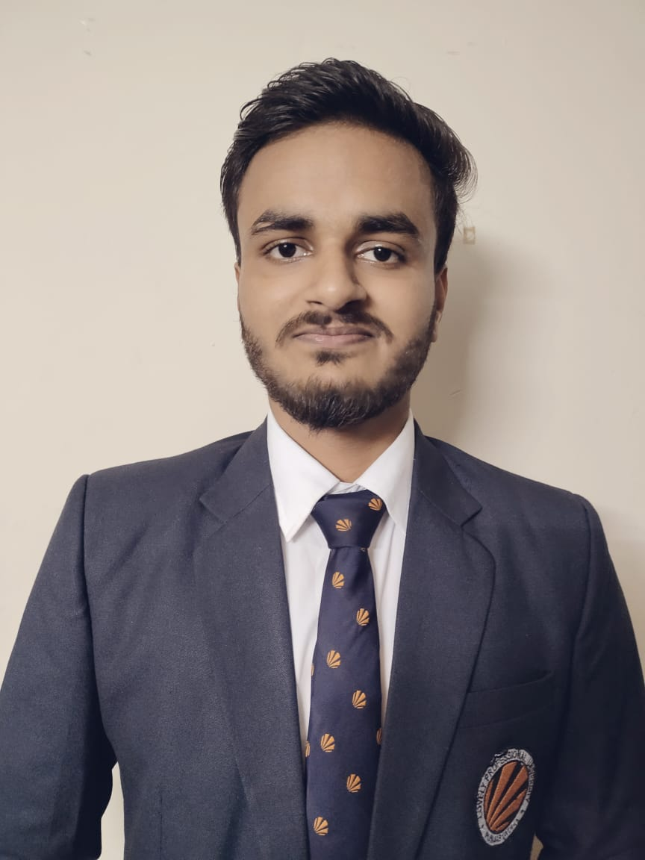

PRAKHAR KATIYAR



https://www.linkedin.com/in/prakharktr

Pkatiyar@gmail.com

SOFTWARE ENGINEER

Kanpur, Uttar Pradesh



https://github.com/Prakhar574



SUMMARY PROJECT

Strong in design and integration with intuitive problem-solving skills. Proficient in java,html,css,javascript and SQL. Passionate about implementing and launching new projects and Ability to translate business requirements into technical solutions, looking to start the career as an entry-level software engineer with a reputed company.

TECHNICAL SKILLS

Programming languages: Java, JavaScript, Bootstrap, C, C++

Web Technologies:

HTML5, CSS,ReactJs.

Data Management: Rapid Miner

MySQL

Platforms: Linux

CERTIFICATIONS

Seminar-Ethical Hacking Workshop

Beginning C++ Programming-

From Beginner to Beyond

POWER SKILLS

* Discipline
* Leadership Capabilities
* Curious
* Enthusiastic
* Good-Communicators

EXTRA CURRICULAR ACTIVITIES

* A Competition on Digital Presentation Jan'18
* Held At-Swaraj Old Age Home, Kanpur Contribute to Support, Serve & Encourage Old & disabled. persons of Swaraj Old Age home

PROJECTS

Online Result Site Sep'21

Domain: Web Application. Languages: Python with Django Framework.

* Web application made up of 2 parts.
* The first part is a public site that lets the user choose between a faculty member on a student that gives the user the option.
* Depending upon what he is to login, view, create student account, Change or update marks.
* Second part is of an admin site that lets the admin add/delete account of faculty and

Blood Bank Management System Oct'22

Domain: Desktop Application | Language Java Swing, MySQL

* Developed a Desktop application in Java.
* Donors can enter their details and can donate blood at the nearest.
* Users can get the blood group from the nearest point by entering his/her detail in the portal.

ACHIEVEMENTS

Inter house Science Project Competition Jul’18

Held At- N.L.K.V.M Inter College | Vishnupuri, Kanpur

Project Title-Smart Home

Secured 1st position.

EDUCATION

M.C.A (Master of Computer Application) Aug’22-Present

Lovely Professional University | Phagwara, Punjab

CGPA 7.77

B.C.A (Bachelor of Computer Application) Apr’22

Dr. Virendra Swaroop Institute of Computer Studies | Saket Nagar, Kanpur

CGPA 7.1

Higher Secondary Apr’19

N.L.K.V.M Inter College | Kanpur.

CGPA 7.9